**Permission Sets**

**Creating A Permission Set**

|  |  |
| --- | --- |
| **Team id** | AD47707C5D4D5109D5E480002BDB30D5 |
| **Project tittle** | Build an Event Management System using salesforce |

From setup search “permission sets” in quick find and select **permission set** then click on **New**

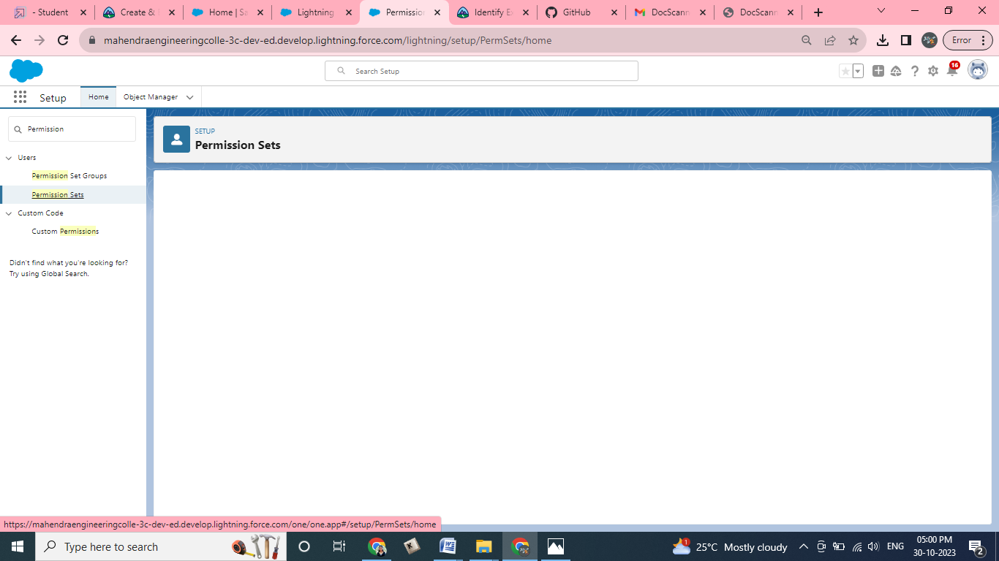

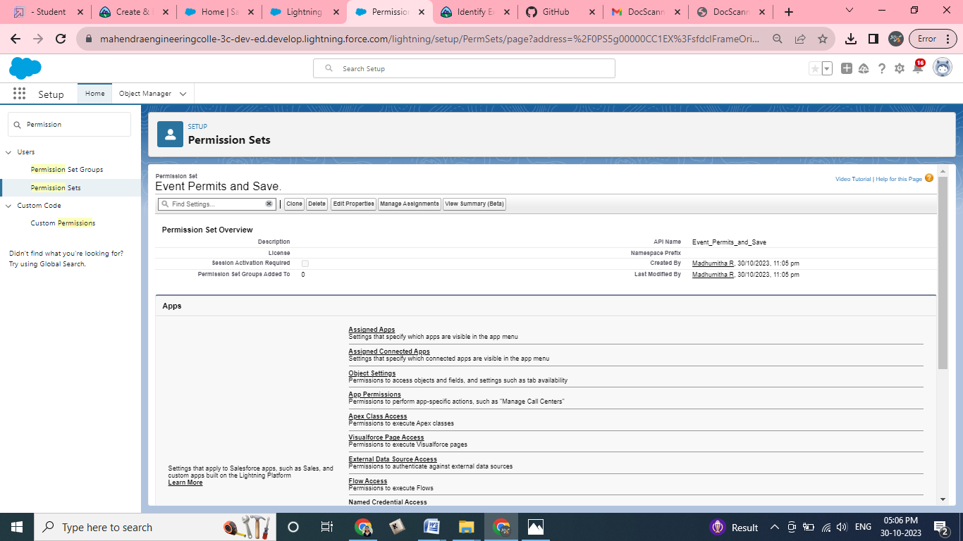

* Enter label as: Event Permits and Save.
* After saving the permission click on the Manage assignment
* Now click on the Add Assignment

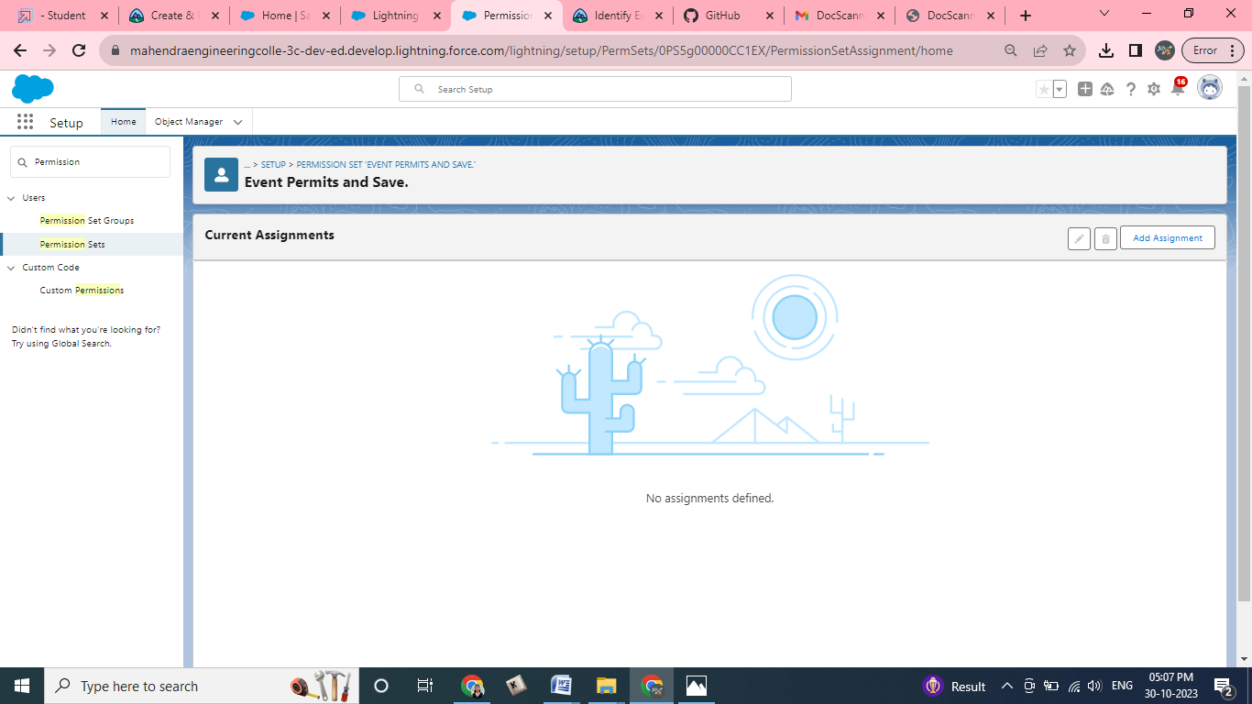

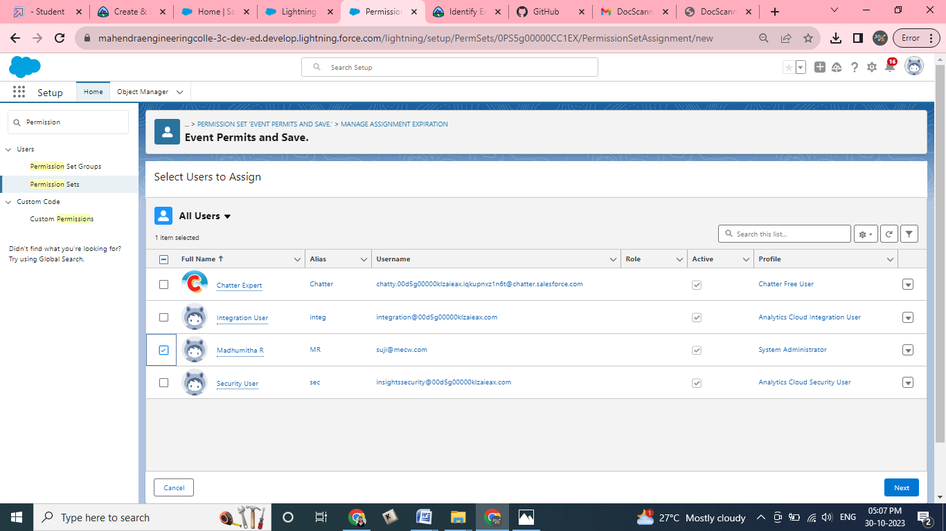

* Now select the users which you create and click on next Assign ,Done

